Headless
By Andrew Smith

A Conan RPG adventure for four 2nd-4th level characters

GM Notes:
I have some “GM Tricks” sections littered throughout this document. Maybe you see my GM style as “cheating” or “underhanded”. However, in my opinion the best role-playing games are those where the players feel as though they have all the free will in the world, but the adventure is railroaded enough that the GM can prepare encounters and plot twists that are satisfying. To this end, I typically have some tricks up my sleeve to provide these surprises for my players. I explain these tricks in the sidebars marked “GM Tricks”.

I have included my sketches in this adventure as well. Make no mistake that I don’t consider myself a great artist by any stretch. On the other hand, I like pictures. Please don’t mock me.

Synopsis:
The player characters are hired by a Zingarian merchant/nobleman to steal a map from a heavily guarded manor of a Stygian expatriate. The heroes find the map tattooed to a lovely mute south island woman. When they return with her, they learn that the nobleman patron does not yet have payment, but instead needs the character’s help to secure the prize first. The heroes have no choice but to help their patron venture to the island. The heroes find themselves shipwrecked on this island full of fallen civilizations, savage pygmy cannibals, a powerful sorcerer, and an active volcano. Can they make it out alive?

Dramatis Personae:

Romeo (“Row-may-oh”) , is the character’s patron. He is the youngest son of a Zingarian merchant/nobleman. As such, he has spent his time as a dilettante spending his father’s money and partying his nights away. However, he has spent some time with his friend Renudo growing up and as such he did some of the studying his friend did. He is an accomplished alchemist, but he does not know any sorcery. He knows that Renudo is seeking something of great value and has jumped at the rumor that a map has appeared showing where his old friend is.

Renudo (“Rey-new-doe”), is a powerful Zingarian sorcerer who has traveled the world in search of the Golden Lotus. From studying the ruins of a fallen civilization that once grew the Golden Lotus as Xuthal had, he has created an elixir that will prolong his life indefinitely despite any bodily harm that may befall him.
GM Tricks:

Irony is defined as “Incongruity between what might be expected and what actually occurs”. By making the manor owner a Stygian, players will just assume that he is a powerful sorcerer. In truth, Renudo the Zingarian is the more powerful sorcerer in this adventure.

Unfortunately for Renudo, the elixir also prevents any healing. The native pygmies of the island have beheaded the sorcerer, leaving him defenseless. Renudo has sent his trusty demon servant back to Zingaria to try and return with help.

Although Renudo is not a Stygian, he is more powerful than Mekakset by far. The player characters should find him charming, capable, and completely evil. By the end of this adventure, smart players will leave him alone.

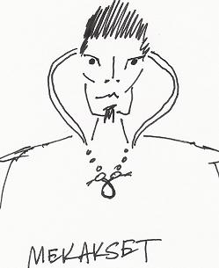
Mekakset (“Mek-ack-set”) is a Stygian nobleman, expatriated from his homeland to Zingaria for the purpose of making money. The handsome Stygian is obsessed with wealth, the enjoyment of wealth, and the pursuit of wealth. Consequently, his magic has suffered. Should he ever go back to Stygia, he would truly be mocked. The only sorcerery style he even knows is Divination for the purposes of finding the best deals.

Lug (“Luhhhhg”), is Mekakset’s trained attack barbarian. This guy is completely nuts. Play him as unhinged and psychotic as possible. If a PC picks a fight with him, have the Cimmerian pull the PC to pieces and then humiliate that unfortunate in an appropriate way. When Lug is with his cadre of goons, he should be nearly unstoppable against the entire group of PCs.

The Mute South Island Woman provides the hook for the player characters to travel to the southern island. Although she understands any language, she will not speak under any circumstance. She is immune to all kinds of harm and will not fight back. This alone should interest player characters enough to make the trip. The truth is that she is actually Renudo’s servant demon.

Jool (“Jewel”), is the pygmy witchdoctor who has kept Renudo’s head from the fires of the volcano. If one were superstitious, that person would say that it was Jool’s folly that brings about the eruption of the volcano and the eventual extinction of the pygmies. Either way, Jool is extremely evil who will gladly sacrifice his own people to gain more power.

Possible Player Hooks:

I simply sent the following email to my players a week before the adventure, but the GM could easily put Romeo in any sorts of situations where he might be able to get the player characters’ attention.
“The group meets their new patron by happy circumstance. A young Zingarian merchant named Romeo happened upon the group as you drank and whored yourselves silly in a flophouse. He promised you each fifty pieces of gold each to help him recover a map that he says has been stolen from him.
Apparently, this map was sent from a friend of Romeo’s named Renudo who had been developing ‘new and exciting trade opportunities’ in the South. Romeo believes that yet another merchant is behind the theft. Mekakset holds several lucrative mines in the north near the Pictish border. Romeo maintains that Mekakset holds the map at his estate at the foot of the Rabirian Mountains near the small village of Evrona. When asked for proof that Mekakset holds the map, Romeo tells them that the merchant plans to make an extended voyage personally in the next few weeks and that he has already begun to make ready three of his finest sailing vessels in the port of Genovla, about forty miles North of Kordava. After picking up the party’s extensive bills for the evening, the deal is set. All the heroes make the trip to Zingara to play their burglary of Mekakset’s estate. “
Did Mekakset really steal the girl from Romeo? Is Romeo just trying to get a piece of something he knows relates to his old buddy Renudo? That is up for the GM to decide later. For now, all you need to know is that Renudo is in trouble and he has sent his servant to try and return with help.

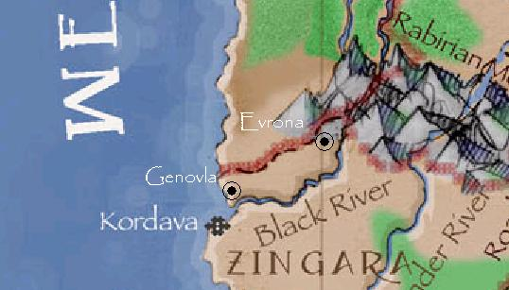

Act 1, Scene 1: Rumors in Genovla

Genovla is a bustling port town of Zingaria that caters to the mining trades that bring their ores to the port town to ship across the world. Some of the best iron and silver ores are shipped out of this town. Zingarians generally regard the noblemen/merchants of Genovla as boorish tightwads, and for the most part that stereotype would be true. With the Stygian Mekakset growing in power, few can spend money on extravagance nowadays.

Those spending some time in Genovla might be able to turn up the following rumors about the Stygian Mekakset and his manor.

- Mekakset is a powerful sorcerer (true except for the ‘powerful’ part)
- Mekakset uses several body doubles to prevent assassination attempts (true)
- Mekakset has disfigured several young women as part of his demented idea of wooing (true)
- Mekakset has built several deathtraps into his manor (true)
- There are several deathtraps in Mekakset’s manor that are set off by pulling a series of velvet ropes that hang from the ceiling or emerge from the floor (false)
- Mekakset has recently returned from a trip to the South with a lovely south island slave girl with the most unusual tattoos. (true)
- Mekakset had recently had a demonstration at his manor to drum up financing. The demonstration included a South Island woman whose body miraculously healed after being stabbed repeatedly in the gut. (true – but not because of any healing magic; the South Island woman is a demon)
- Mekakset has a series of trade warehouses on the docks that service a fleet of eight vessels that travel the coast trading between Zingaria and Stygia. Mekakset’s trade house is named “The Styx Trade Company”. (true – Mekakset is perhaps the most powerful trading houses in Genovla)
- Don’t be raising trouble in Evrona. All those in that mining town work for the Stygian, Mekakset. They won’t take kindly to those who threaten their master. (true for those in Mekakset’s employ – the rest of the town simply complies out of fear of reprisals)

Act 1, Scene 2: The Evrona Area

- Evrona Proper  - Mekakset’s Estate  - Iron Mine  - Kukirk Creek  - Small Forest | 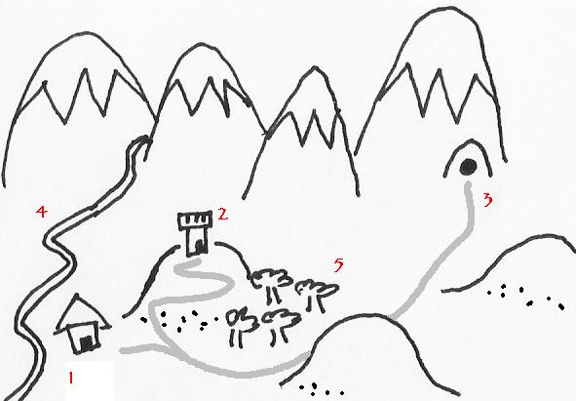
Evrona is a small mining town built by Mekakset to mine the iron found in the Rabirian Foothills. It is a depressing little burg with many terrified and mirthless townsfolk oppressed by loud, boisterous miners and soldiers in Mekakset’s employ. Every payday, these miscreants descend on the little town to spend some of their money and have a huge party. The next two weeks consists of these poor peasants trying to put their lives back into order for the next assault.

If the PCs appear as fearless mercenaries on a shady mission, they will fit right in. If they lay low, and don’t show their faces on payday, they should have no problems moving about virtually at will.

The PCs might be able to hide in the small forest at the base of the hill that the estate stands on and perhaps waylay a caravan that comes by. Alternately, PCs that investigate the working mine (area 3) might be able to find the secret passage that leads to the underground workshop below the estate. A search check (DC 25) or an appropriate mining/stonemasonry craft check (DC 15) will turn up the 5’ wide passage.

Act 1, Scene 3: Breaking into Mekakset’s estate

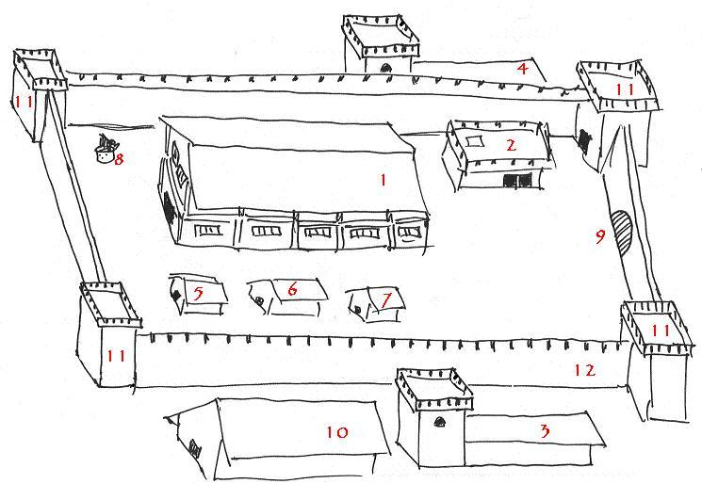 | Mekakset’s Estate  - Manor House  - Warehouse  - Barracks  - Barracks  - Cookhouse  - Pantry  - Kennels  - Well  - Front Gate  - Stables  - Watchtower

For breaking into the estate, the players should feel like it is a real challenge. In reality though, you want the PCs to succeed in finding and stealing the map from Mekakset for the adventure to progress. Give the PCs some time to make a plan. There are guard dogs, outriding patrols, and two guard barracks that could hold “up to one hundred guards each”. As they execute their plan, make lots of hidden dice rolls and grimace a lot from behind your GM screen. However, any plan the players come up with that seems marginally reasonable should succeed. Perhaps the guards on the wall are far-spaced and inattentive. Maybe you could rule that the guard barracks are full of sleepy drunks from a night of boozing. Use your own judgment on how many guards should stand in the PCs way. I even went as far as insisting on rolling the PCs rolls for them “so that they would not know for sure whether they were found or not". In reality, it was so that I could fudge any stealth rolls the PCs made until they had the South Island girl and realized she had the map tattooed on her.
GM Tricks:
I always find that villains are best if the players get a preview before they fight and subsequently kill them. I figured that perhaps Mekakset enjoyed being tied up and beaten himself, and had the PCs first meet him helpless and tied up in his personal torture chamber. The player characters got to meet him, which made the final encounter that much more satisfying. If you have paranoid players who eventually kill the fellow tied up in Mekakset’s torture chamber, you could always rule that the man was merely one of Mekakset’s body doubles who took on a little too much of the Stygian’s power.

Once the PCs have her though, be sure to demonstrate the full weight of the force that could come down on the PCs. You need to make a convincing show of force to make sure the players don’t decide to take their time and loot Mekakset’s home and warehouse instead.

Successfully leaving the manor with the lovely South Island Girl wins all the looters who were seen by guards two fame points. It takes true grit to poke a Stygian in the eye and live to tell the tale, and the PCs have just done that in spades

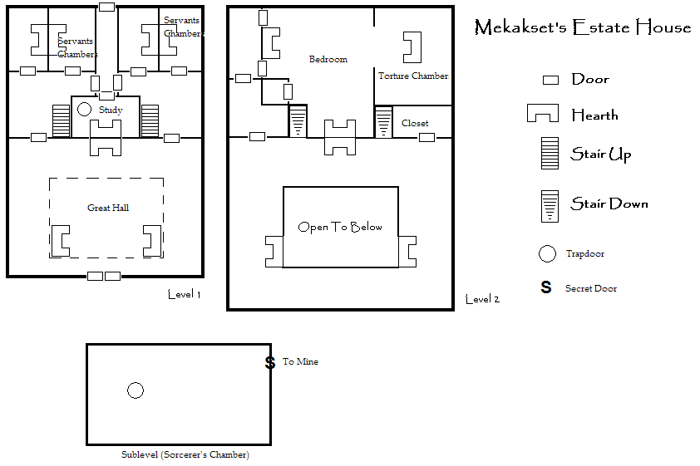

Act 2, Scene 1: Going on a boat trip

Romeo must convince the PCs that he does not have the money, but instead explain that he can get the PCs more golden wine if they come with him to the island on the map (which is on the girl). Romeo makes a copy, but it is indeed flawed since he is not a true mapmaker.

Romeo believes that this map was made by his friend Renudo who is himself a very accomplished sorcerer. Romeo is in fact an accomplished alchemist and he believes that he can come up with the golden wine once he has the raw golden lotus. Other than that, Romeo will provide a good healer and herbalist for the group.

Romeo charters a small Zingarian ship. Assume it is the same as a Stygian gondola from the rulebook and some Zingarian pirates for a crew.

Explain the drowning rules to the PCs. They will need them. Many of the wise players may decide to leave their heavy armor and weapons at home.

Remember that the lovely South Island woman never speaks. However, she can understand any language and will respond with a glare or a smile as appropriate. She will never give away her identity as a demon until she is in the presence of her master. A situation that might have a great payoff should one of the player characters decide to attempt to woo the “cold, but lovely Southerner”.

Act 2 Scene 2: The Sea Monster

Mekakset’s three vessels race to pursue the player characters’ vessel. They are always on the horizon, dogging the PCs as they travel southward.

A giant sea monster is glimpsed. Its head is easily half the size of the boat with a jaw filled with razor-sharp teeth. The rest of its body twists away like a gigantic snake. One afternoon, it will be seen at a distance by only the one character with the best spot score. In the evening one or two characters will see it several hundred yards from the ship. Right at dusk, all the PCs will get to see the monster surface and peer right at the ship. Begin asking the players what they all do during the first, second, and third part of the night. The sea monster will never attack, but it is worthwhile reminding the players that there are things that even they could never defeat.

Act 2 Scene 3: The Dead Rise to Kill

The PCs come into sight of their goal. Evening approaches, and a powerful lightning storm forms over the island. When the PCs reach a point about two miles from shore, the storm moves to engulf the heroes’ ship, as if guided by some sort of malign intelligence. As the rain from the storm starts to pound the deck, headless undead putrid with seawater and blue congealed blood start climbing onto the ship. The headless zombies start to tear the vessel apart board by board and pulled underwater. The ship is destroyed and dragged to the bottom of the sea along with all the loot and equipment on it.

The player characters can fight the zombies, but keep sending them in waves to continue to break the ship. After five rounds of combat, describe the ship literally cracking in half as zombies burst their way up from underneath the hull of the boat. The PCs now have a decision to make. They are going to have to swim without the benefit of any flotation from the ship as each and every sliver of timber and equipment from the vessel are sucked underwater.

These zombies are the fallen civilization of the dreamers. They wear the ruined finery of an old, decadent society that was beheaded in their sleep when the first pygmies arrived on the island. Now the bodies of the long dead are a curse on the island marooning all who venture near.

Because of the raging storm, the PCs must make a DC 20 swim check to reach the island safely. Remember that each 5 pounds of armor and equipment count against the roll. If the PCs fail the roll, allow them to drop any equipment that might help them survive and make another roll with a –5 penalty. Eventually, all the PCs will either reach safety or eventually be unable to roll above their target number and drown. Those that drown must spend a fate point. They will be found bound and prepared for beheading by the pygmies later in the next act. They will have lost all their equipment to the sea.

Act 3 Scene 1: Island of the Headhunters

PCs awaken on a deserted jungle island. As the PCs first start to explore the island, they encounter a small earth tremor. Foreshadowing of the full volcanic eruption that happens at the end of the adventure.

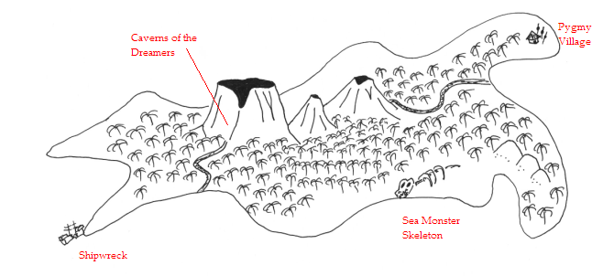

A parrot may befriend one of the pirate adventurers. What could be cooler if you were a pirate? If the pirate character offers a hand or shoulder to the bird, it becomes theirs. The parrot provides a +1 bonus to intimidate rolls, but is otherwise useless.

The PCs spot that first pygmy spying on them. At first the pygmies seem benign. They spy and follow, but do not engage.

Then PCs find pygmies cutting off the heads of NPC sailors/pirates who managed to swim through the storm as well. The last remaining sailor is just going to his gory death as the players approach the pygmies. The only ones that remain alive are Romeo, the South Island Girl, and any PCs that were forced to spend a fate point to avoid drowning. PCs will probably spring into action to free their friends. PCs who spend a fate point can break the Pygmies’ binds with an escape artist or strength check of DC 21. There are few enough pygmies that they lose easy (1 pygmy brave per pc + 1 witchdoctor).

Act 3 Scene 2: Traps

Traps dog the PCs next.

Pit traps to slow lead party members down (Reflex Save DC 15 for the first PCs in the marching order or fall in for 1d8 points of damage).
Avalanche trap by the craters (Each PC attacked by three boulders +0 to hit, 2d6 points of damage).
Pungi stake on a bent branch attack.

At each trap site, pygmies ambush, throw javelins and escape in all directions into the jungle. Make spot rolls against the pygmies hide skill. I just assumed that the pygmies all take 10 on their hide skill. That means that PCs must get a spot of DC 17 to detect that they are walking into a trap. These ambushes should include 1 brave and 1 sneak per PC.

Act 3 Scene 3: The Pygmy Village

The pygmy village will be empty if the players visit it. It looks as though the inhabitants have left in a hurry. They are all out by the active crater appeasing their lava god with prayer and sacrifices of human heads. End this scene with another tremor and a puff of black ash thrown up by the active volcano to give PCs a hint about the location of the pygmy nation.

Act 3 Scene 4: The Sea Monster Skeleton

This is the exact same type of monster that the players glimpsed on the ship. Go out of your way to describe just how huge it is. The monster bones may be of some use to alchemists if a sample is taken. Perhaps 10sp/pound of bone.

Act 3 Scene 5: The Shipwreck

An old shipwreck is beached on some sharp rocks on one side of the island. Exploring the wreckage finds a lot of headless skeletons. Weaponless PCs can find one rusty cutlass and poniard each.

Act 4 Scene 1: The Pygmy Nation

Romeo will lead the PCs toward the caverns of the dreamers, a prominent spot marked on the South Island woman’s back. There they will find the pygmy army praying to the rumbling volcano above them. They all chant in a strange South Island dialect, “Skulls and Brains appease the flames”. Nearly a hundred pygmies turn to face the approaching PCs. The pygmy nation includes common villagers as well as braves, sneaks, and three witchdoctors including the mysterious Jool.

Jool has a bag that he listens to constantly throughout the battle. In it is the head of Renudo, still alive whispering blasphemous words of sorcerery to the pygmy witchdoctor.

I started with the Jool summoning his two forest elemental thralls and throwing them at the PCs as the pygmies circled around the players cutting off their retreat. Once the elementals were defeated, I continued to throw waves of pygmies at the players, with Jool raising his fallen comrades from the dead.

Keep piling the attacks on until one of the characters falls. Just as things look hopeless for the characters, the volcano grumbles. The pygmies either run or fall prone on their knees in fear.

Act 5, Scene 1: The Caverns of the Dreamers:

The PCs eventually find the caves covered in rubble. Once a magnificent brown sandstone monolithic temple, the place is collapsing and full of rubble. Renudo’s body is here, with no head. His head as been cut off by the pygmies. The body points to some warm, dark pits where at the bottom, gold lotus grows from piles and piles of skulls. There must be several acres of the lotus in the darkness lit by some slow-moving molten lava farther down.

Everywhere the players see golden couches that the dreamers slept on. Everything is very warm from the volcano about to erupt. The South Island woman takes Renudo’s head from where Jool had dropped it (either as he fled or was killed by a player) and reunites it with the Zingarian sorcerer’s body. PCs watching the strange woman calmly produce a needle and thread and sew the head back on to the body must make a fear roll at DC 10 or become shaken (-2 to any attack or skill roll) for the next ten melee rounds. Renudo is pleased to be back, but he has bad news. Mekakset and his goon squad arrive along with the Cimmerian Lug and some guards. The Stygian wants a pound of flesh from the PCs for breaking into his estate.
GM Tricks:
I have not included stats for Renudo for two reasons. First, he is virtually immortal and cannot be killed. Even beheading was not enough to stop the Zingarian. Second, players should be insane to take on a powerful sorcerer when the Stygian is clamoring for their deaths. Furthermore, the gifts of the golden wine should ensure that Renudo makes his getaway.

Out of the frying pan, into the fire. Renudo gives each PC a dose of the Golden Wine of Xuthal to re-invigorate them. The PCs must fight their way out of the caverns of the dreamers.

Once Mekakset falls, the PCs see Renudo fly from the site on the back of a big, black, demonic camel. The South Island Woman is nowhere to be found (she turned into the camel). Another tremor hits the island. The volcano starts to erupt. The PCs must then fight/convince their way to take Mekakset’s ship (which was anchored on the other side of the island) and depart.

Epilog:
Who was that Renudo guy? The powerful Zingarian sorcerer kind of owes the PCs a little debit for saving him from his fate. What happens to Mekakset’s estate with him dead? Perhaps the PCs could turn to a life of piracy once they are able to take over Mekakset’s ship?

